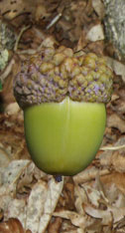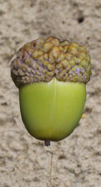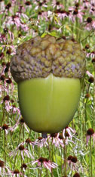

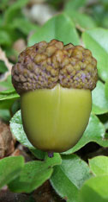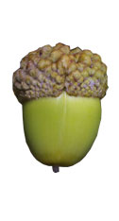

Fig. 1.2. Cards of large acorns for use in Activity 1 with five different habitat backgrounds (from top left: brown, desert, floral, green, and white). To generate cards of small acorns for this activity, reduce images by 50%. See Figs. 1.3 and 1.4 for corresponding text for the back of the cards.

