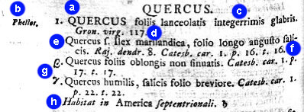

Fig. 2.2. Student handout: Sample oak species account in Species Plantarum (Linnaeus 1753). Please provide an explanation of each labeled feature:

a (example): Quercus is the genus name.

b: What part of the scientific name does Phellos represent?_____________________________

c: The phrase QUERCUS foliis lanceolatis integerrimis glabris (oak with leaves lanceolate, entire, and smooth) represents what kind of botanical name? _________________________________

d: What is Gron. virg. 117? Is it part of the scientific name or a bibliographic citation (circle one).

e: This phrase looks similar to the one above. Is another species listed here? Is it different from the one above? ______________________________________________________________________________________________________________________________________________________________

f: What is Raj. dendr. 8 Catesb. Car. I. p. 16, t. 16? Is it part of the scientific name or a bibliographic citation (circle one).

g: What do you think the greek characters represent?
______________________________________________________________________________________________________________________________________________________________

h: What is the informational purpose of this phrase? ______________________________________________________________________________________________________________________________________________________________

