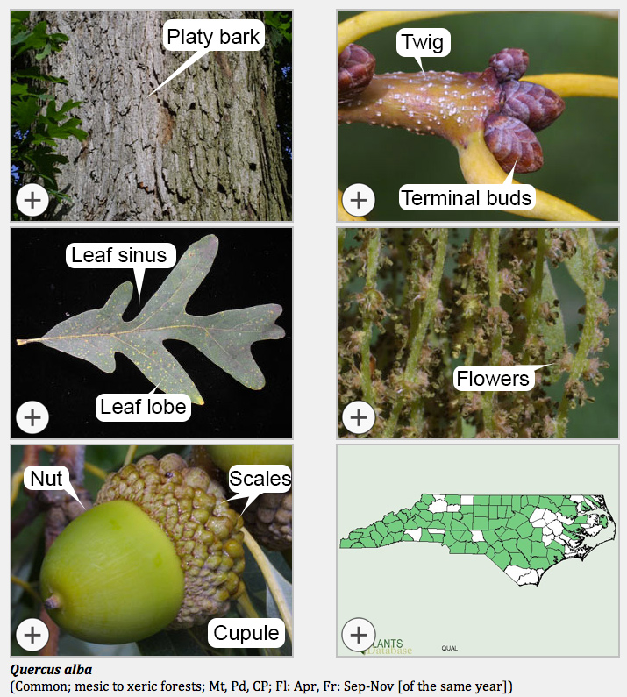

Fig. 2.3. Student handout: Some morphological features of oaks, using white oak as an example (Quercus alba). From: Trees of North Carolina Working Group (TNCWG). 2014–present. Trees of North Carolina. Version 1.0. North Carolina State University, Raleigh. [http://herbarium.ncsu.edu/tnc/]

