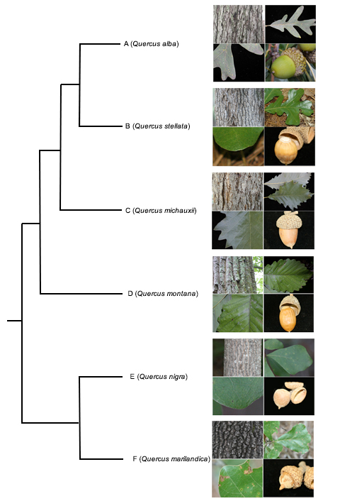

Fig. 3.2. UPGMA phenogram of six North American oak species.

