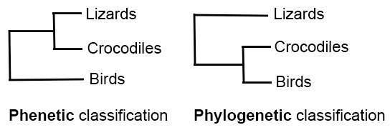
Fig. 4.1. Two classification schemes: Phenetic (left; based on morphological similarity) and phylogenetic (right; based on evolutionary relationships). Diagram after Ridley (2003).

