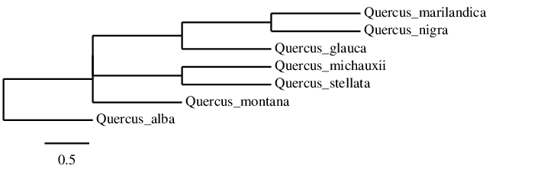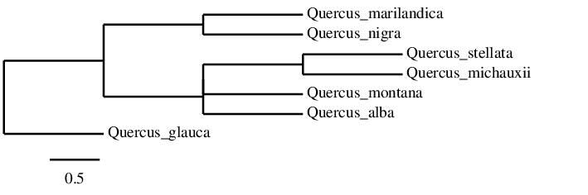
A.
B.

Fig. 4.5. Phylogenies of select oak species based on the nuclear ribosomal internally transcribed spacer (ITS): A. Phylogeny based on ClustalW alignment. B. Phylogeny based on MUSCLE alignment. Phylogenies were generated at phylogeny.fr using TNT (sectorial search, tree fusing).

