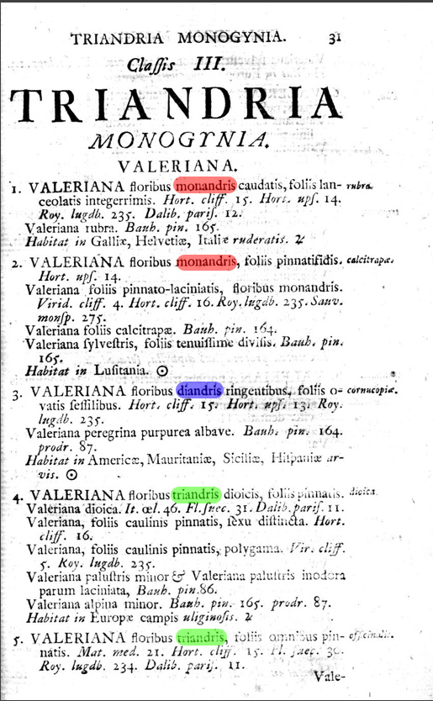

Fig. 5.1. Excerpt from Linnaeus’ treatment of Valeriana in his Species Plantarum (1753), showing grouping of species with a single, two, or three anthers all within his Three-anther class (Triandria). Courtesy of the Peter H. Raven Library, Missouri Botanical Garden.

