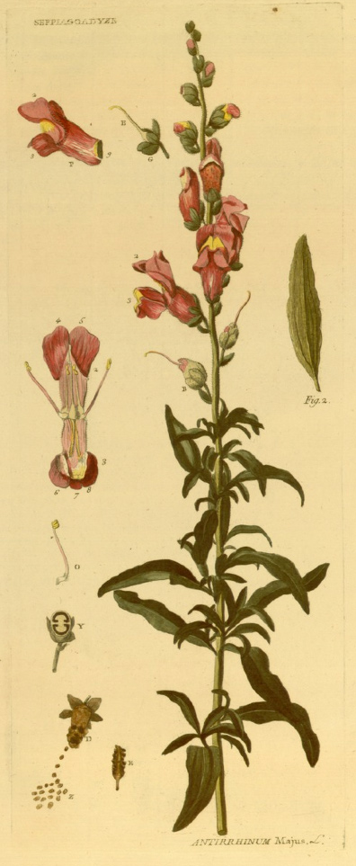

Fig. 5.2. Illustration of snapdragon (Antirrhinum majus) from Bergeret’s Phytonomatotechnie universelle (1873-1874). Bergeret’s name is printed in the top left corner (SEFPIAGOADYZE) and the Linnean name in the bottom right (Antirrhinum majus). Courtesy of Biblioteca Complutense, Universidad Complutense de Madrid.

