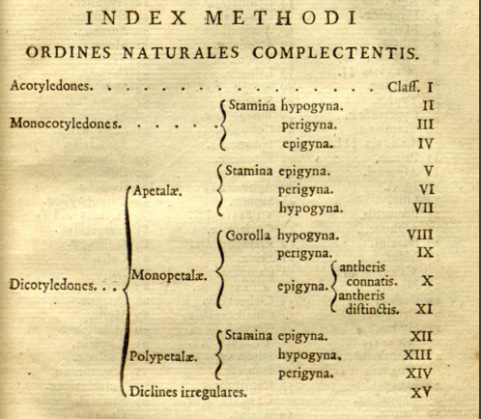

Fig. 5.3. Classification scheme from Antoine-Laurent Jussieu’s Genera Plantarum (1824). Courtesy of the Peter H. Raven Library, Missouri Botanical Garden.

