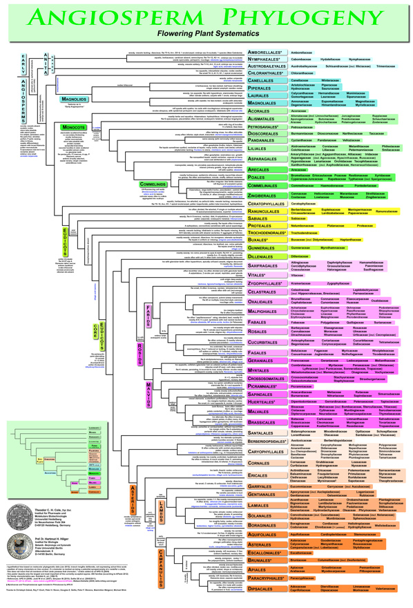

Fig. 5.4. Flowering plant (angiosperm) tree of life derived from APG III. Courtesy of Freie Universitaet, Berlin.

