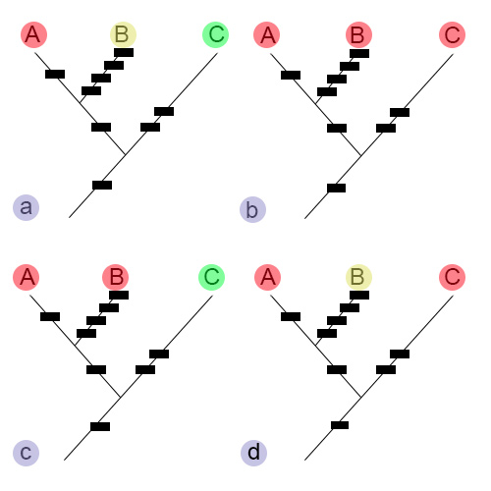

Fig. 5.5. Relationship of three species (A, B, and C) that could be classified in numerous ways, including: (a) consider all species monotypic and thus give each their own genus, (b) consider them all in one genus, (c) consider A and B in the same genus, but place C in a separate genus, (d) consider A and C in the same genus, but place B in a separate genus. Black rectangles represent character states that have diverged.

