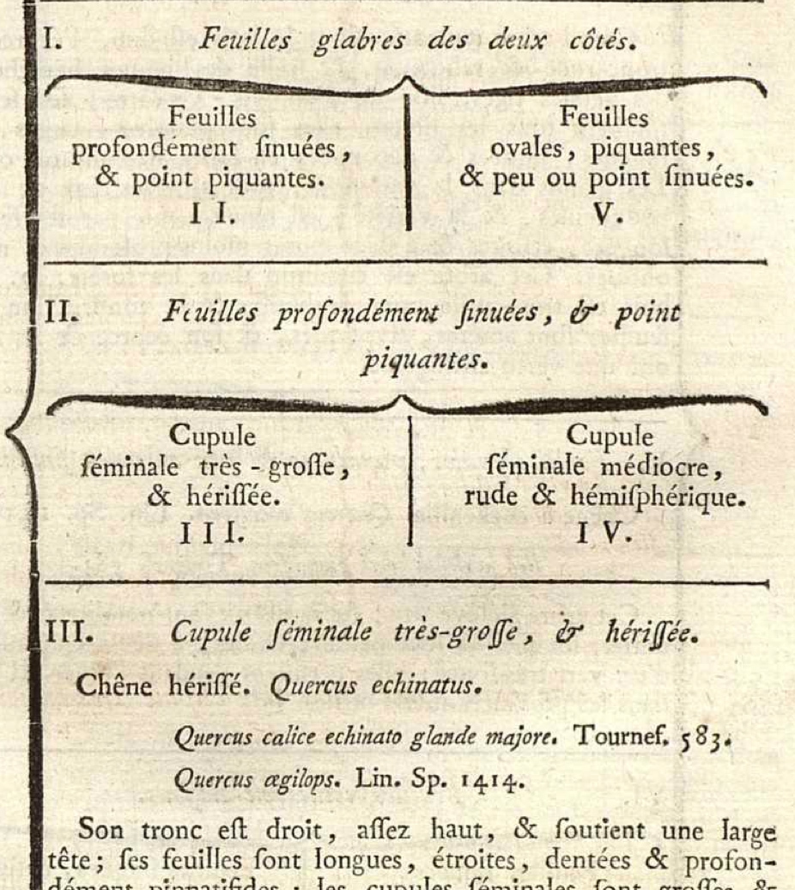
Fig. 6.1. Excerpt of oak treatment from Flore françoise (Lamarck 1779), perhaps the first flora to introduce analytic identification keys. Courtesy of Biblioteca Digital del Real Jardín Botánico de Madrid.

