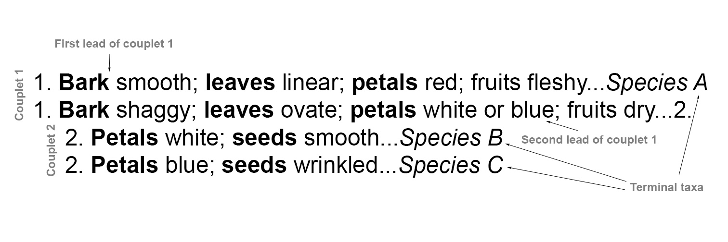
Fig. 6.3. Anatomy of a dichotomous key. Dichotomous keys are composed of two contrasting statements (“leads”), these together referred to as “couplets”. The terminal units can be of any taxonomic rank (e.g., order, family, genus, species, subspecies, etc.), depending on the objective of the key. Terminal taxa (species in the above excerpt) in terminal couplets are typically arranged alphabetically. Characters in each lead must be parallel and contrasting.

