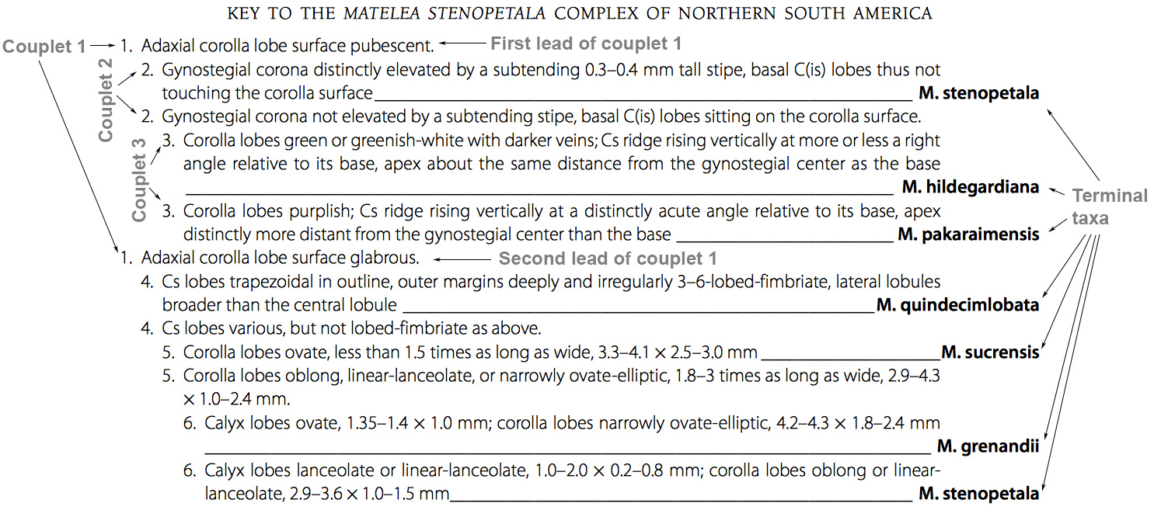

Fig. 6.4. Sample dichotomous key (based on Krings 2011). Note the alphabetical arrangement of terminal taxa in terminal couplets.

