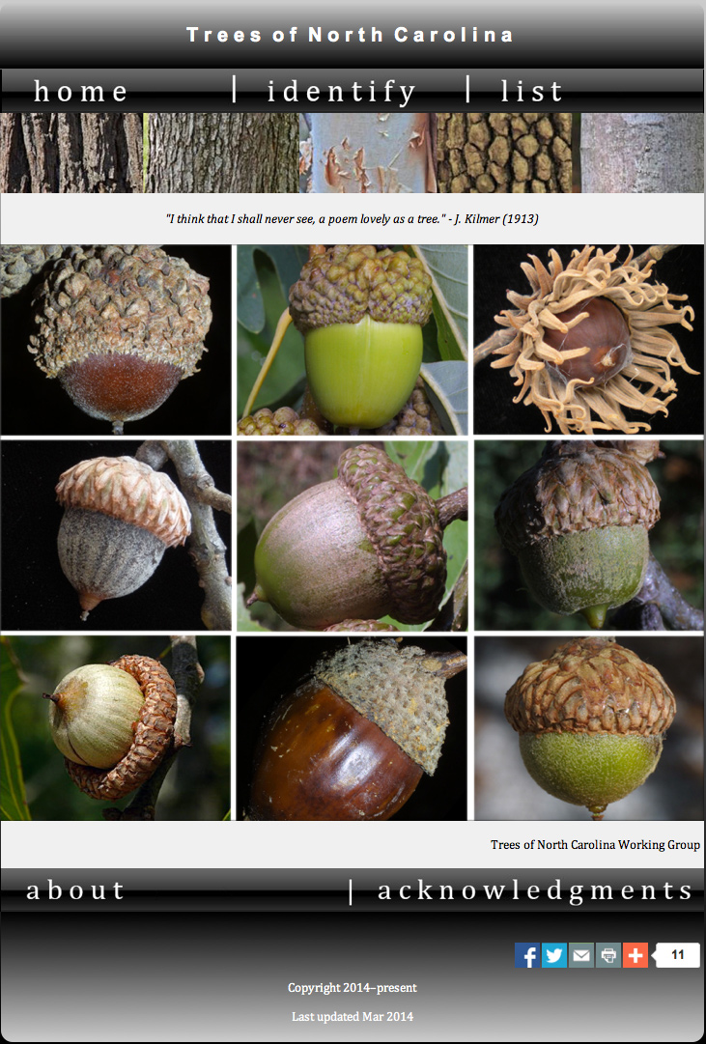

Fig. 6.5. Trees of North Carolina: An online and mobile app (TNCWG 2014). http://herbarium.ncsu.edu/tnc

